**RECIPE BOOK & MEALPREP**

CP Lab Project

BISMA IMTISAAL

01-134251-016

Sir Mohsin Javed

BAHRIA UNIVERSITY ISLAMABAD CAMPUS

Contents

FINAL PROJECT REPORT 1

Introduction 1

Main features 1

1. Recipe Management 1

2. Three-Ingredient Recipes 2

3. Weekly Meal Planner 2

4. File Handling and Utility Functions 2

5. User Interface and Menu System 3

Code Structure 3

Functions 3

1. Recipe Functions 3

3. option1_code(string& file_name, string& recipe) 4

4. delete_code(string& filename) 5

5. update_code(string& file_name, string& recipe) 6

6. ing3_recipes() 7

7. menu() 7

8. main_work() 7

9. Mealprep Structure and Weekly Meal Functions 8

Summary: 9

Links 10

# FINAL PROJECT REPORT

# Introduction

The Recipe Book project is a C++ console application designed to help users manage, view, and organize a variety of recipes. The program provides an interactive menu-driven interface, allowing users to search, read, update, delete, and create new recipes. It also features a weekly meal planner and a collection of quick, three-ingredient recipes for convenience. The application uses file handling to store and retrieve recipe data, ensuring persistence across sessions.

## Main features

### Recipe Management

The core functionality revolves around recipe management. Users can **search** for a recipe by its serial number, **read** its contents, **update** or **delete** it, and even **add** new recipes. Each recipe is associated with a unique file, and the program uses file I/O operations to perform these tasks. The menu system guides the user through each operation, making the application intuitive and user-friendly.

### Three-Ingredient Recipes

A special section is dedicated to recipes that require only three ingredients.

User will be asked three ingredients of first recipe if they all are available to use then recipe with those ingredients will be displayed otherwise three ingredients of next recipe will be asked. Users can also just view the list of these simple recipes.T his feature is particularly useful for those seeking quick and easy meal ideas. The program organizes these recipes separately for easy access.

### Weekly Meal Planner

The application includes a weekly meal planner, allowing users to assign recipes to each day of the week for breakfast, lunch, and dinner. Users can create, display, update, or remove meals from their weekly plan. This feature uses a structure array to store meal data for each day, making meal planning systematic and efficient.

### File Handling and Utility Functions

All recipe data is stored in text files, and the program uses file streams to read, write, update, and delete these files. Utility functions are implemented for displaying recipes, deleting files, and updating content. This approach ensures data persistence and modularity in code design

### User Interface and Menu System

The program features a clear, text-based menu system that prompts the user for input at each step. The main menu offers options for all core functionalities, and each choice leads to further prompts and actions. The use of switch-case statements and input validation enhances the overall user experience

# Code Structure

The code is organized into functions for each major operation, promoting readability and maintainability. Recipe functions return recipe content as strings, and file operations handle the storage and retrieval of these strings. The use of structures for meal planning and separate functions for utility tasks demonstrates good programming practices

# Functions

### Recipe Functions

Each recipe function (e.g., biryani(), karahi(), beef_pulao(), etc.) returns a string containing the full recipe text. These functions are called when the user wants to view, update, or create a recipe. This modular approach keeps each recipe’s content separate and easy to manage

1. **Three-Ingredient Recipe Functions**

Similar to the main recipe functions, these (e.g., garlicSoyChicken(), eggFriedRice(), etc.) return the text for recipes that require only three ingredients. These functions support the feature that allows users to quickly find and use simple recipes.

### option1_code(string& file_name, string& recipe)

This utility function displays the contents of a selected recipe. It takes the filename and the recipe string, then outputs the recipe to the user. It ensures that the correct recipe is presented based on the user's selection from the menu.

### delete_code(string& filename)

This function deletes a recipe file from storage. It uses the C++ remove() function to delete the file corresponding to the selected recipe. It provides feedback to the user about the success or failure of the operation.

|  |
| --- |
|  |

### update_code(string& file_name, string& recipe)

This function updates the contents of a recipe file. It overwrites the existing file with new content provided by the user, allowing recipes to be edited and kept up to date.

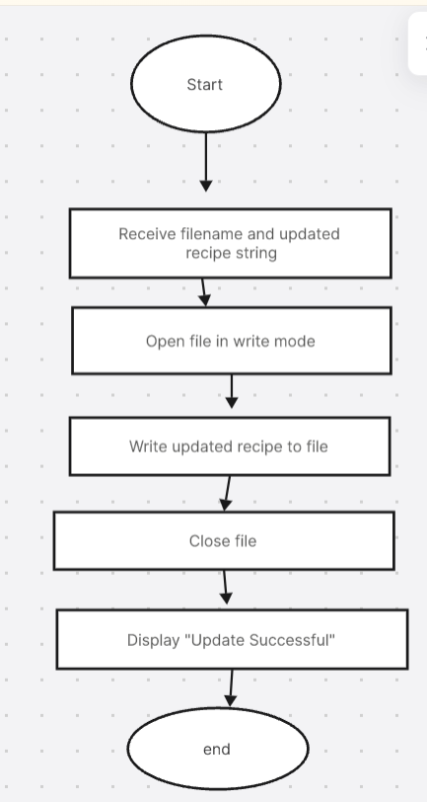

### ing3_recipes()

This function displays a list of all available three-ingredient recipes. It helps users quickly browse and select from simple recipes, improving the user experience for those looking for quick meal ideas.

### menu()

The menu() function displays the catalog of all available recipes, each with a serial number. This helps users see their options and select the desired recipe for viewing, updating, or deleting.

### main_work()

This is the main driver function of the program. It displays the welcome message and main menu, receives the user's choice, and calls the appropriate functions for each operation (search/read, delete, update, create, list recipes, three-ingredient recipes, weekly meal planning, etc.). It uses a switch-case structure for clear control flow.

### Mealprep Structure and Weekly Meal Functions

The mealprep structure holds meal information for each day (breakfast, lunch, dinner). The related code in main_work() allows users to create, display, update, and remove meals from their weekly plan, making meal organization easy and systematic.

# Summary:

The code is organized into clear, modular functions for each major task: managing recipes, handling three-ingredient recipes, displaying menus, file operations (read, update, delete), and weekly meal planning. This structure makes the program easy to use, maintain, and extend

# Links

* **GITHUB:**

<https://github.com/Bisma354-star/1st-programming-project/tree/main>

* **LINKEDIN:** <https://www.linkedin.com/feed/update/urn:li:activity:7332144133232353280/>